Claude Certification — Building with the Claude API
Section 2 — Accessing Claude with the API
Contents
- Lesson 1 — The Request Flow & How Claude Processes It
- Lesson 2 — Making Your First API Request
- Lesson 3 — Multi-Turn Conversations
- Lesson 4 — System Prompts
- Lesson 5 — Temperature
- Lesson 6 — Response Streaming
- Lesson 7 — Structured Data

Lesson 1 — The Request Flow & How Claude Processes It

Core idea
Every interaction with Claude follows a predictable five-step flow. Your app never calls the API directly — it goes through your own server, which holds the secret API key. Inside Anthropic, Claude turns your text into a response through four processing stages.

The five-step request flow
- Request to Server → Request to Anthropic API → Model Processing → Response to Server → Response to Client
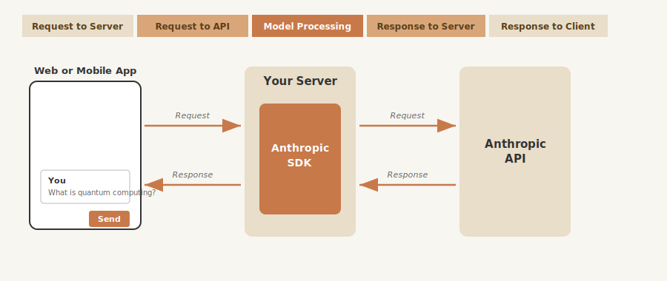
Full round trip: App → Your Server (with SDK) → Anthropic API, and back.

Why you need a server (key security point)
- API requests need a secret API key for authentication.
- Never call the API from client-side code — exposing the key is a serious security vulnerability (anyone could extract it and make unauthorized requests).
- Flow: your app → your server (stores key securely) → Anthropic API.

Making a request
Contact the API via an official SDK (Python, TypeScript, JavaScript, Go, Ruby) or a plain HTTP request. Input text goes inside a "user" message, placed in a list of messages. Four essential fields:
Field | Purpose
API Key | Identifies your request to Anthropic
Model | Which model to use (e.g. "claude-3-sonnet")
Messages | List containing the user's input text
Max Tokens | Limit on how many tokens Claude can generate

Inside Claude's processing — the 4 stages
Once Anthropic receives your request, Claude processes it through four main stages. These are core concepts — worth understanding well:
1. Tokenization
Claude first breaks your input text into smaller chunks called tokens. A token can be a whole word, part of a word, a space, or a symbol. For simplicity you can think of each word as roughly one token, but in practice longer or rarer words split into multiple tokens. This is the unit Claude actually reads and counts (and what you're billed on).
2. Embedding
Each token is converted into an embedding — a long list of numbers that represents all possible meanings of that token. Think of embeddings as numerical definitions that capture semantic relationships between words. A single word like "quantum" carries several possible meanings at this stage (a discrete unit of physical quantity; quantum mechanics/physics; something extremely small/subatomic; quantum computing), and the embedding encodes all of them numerically before context narrows it down.
3. Contextualization
Claude refines each embedding based on the surrounding words to determine the most likely meaning in context. This process adjusts the numerical representations to highlight the appropriate definition — so "quantum" next to "computing" gets pushed toward the computing sense and away from the others. This is where ambiguity gets resolved using the rest of the sentence.
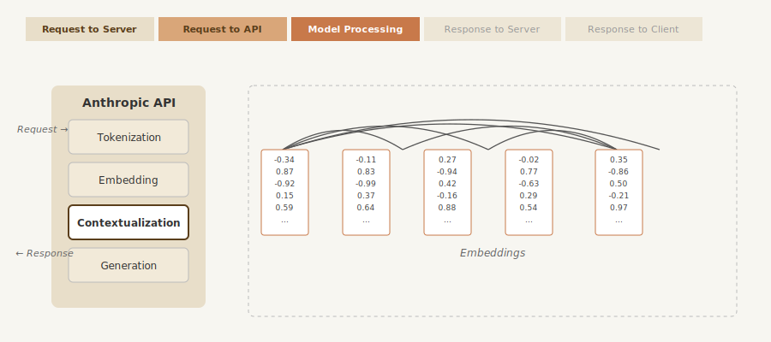
Contextualization: the curved arcs show each embedding drawing on the others to settle its meaning in context.
4. Generation
The contextualized embeddings pass through an output layer that calculates probabilities for each possible next word. Crucially, Claude doesn't always pick the highest-probability word — it uses a mix of probability and controlled randomness to create natural, varied responses. After selecting each word, Claude adds it to the sequence and repeats the entire process for the next word, one token at a time.
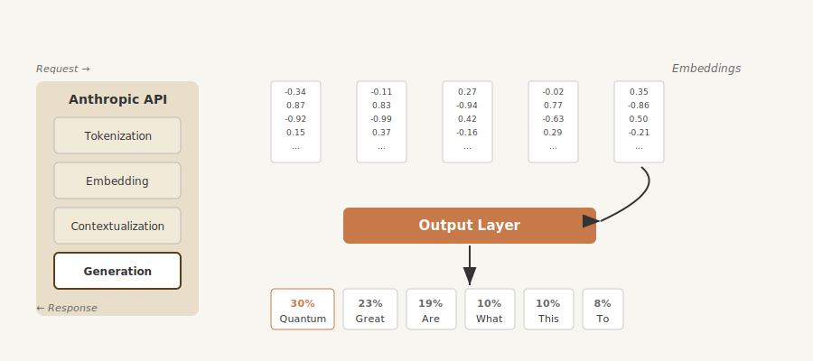
Generation: contextualized embeddings → output layer → probability distribution over next tokens (e.g. 30% "Quantum").

When Claude stops generating
After each token, Claude checks several conditions to decide whether to continue:
- Max tokens reached — it hit the limit you specified in the request.
- Natural ending — it generated an end-of-sequence (EOS) token.
- Stop sequence — it encountered a predefined stop phrase you set.

The API response
When generation completes, the API sends back a structured response. Output text is placed into an "assistant" message. It contains:
- Message — the generated text.
- Usage — count of input + output tokens.
- Stop Reason — why generation ended.
Your server receives this response and forwards the generated text back to the client, where it appears in the user interface.

Practice Questions — Lesson 1
Choose the single best answer for each question (A–E).
1. Why should you never call the Anthropic API directly from client-side code?
A) It would be too slow
B) The secret API key would be exposed, a serious security vulnerability
C) Client code cannot send HTTP requests
D) The API only accepts requests from mobile apps
E) It would use more tokens
2. Which of these is NOT one of the four essential request fields?
A) API Key
B) Model
C) Messages
D) Max Tokens
E) Stop Reason
3. What is the correct order of Claude's four processing stages?
A) Embedding → Tokenization → Generation → Contextualization
B) Tokenization → Embedding → Contextualization → Generation
C) Generation → Embedding → Tokenization → Contextualization
D) Tokenization → Contextualization → Embedding → Generation
E) Contextualization → Tokenization → Embedding → Generation
4. During generation, how does Claude choose the next word?
A) It always picks the single highest-probability word
B) It mixes probability with controlled randomness for natural, varied responses
C) It picks a word at random with no probabilities
D) It reuses the previous word
E) It asks the server to choose
5. In which stage does Claude use surrounding words to resolve a token's most likely meaning?
A) Tokenization
B) Embedding
C) Contextualization
D) Generation
E) Usage

Lesson 2 — Making Your First API Request

Core idea
Before Claude can process anything, your environment needs a securely stored API key and an initialized client. From there, every request revolves around three parameters passed to client.messages.create() — the model, a safety cap on output length, and the list of messages that make up the conversation.

Key points
- Install the anthropic and python-dotenv packages, then store the key in a .env file — never hard-code it, and always add .env to .gitignore.
- load_dotenv() reads the .env file so that Anthropic() can find the key automatically — no key argument needed in your code.
- client.messages.create() requires exactly three parameters: model, max_tokens, and messages.
- Every message is a dictionary with a role ("user" or "assistant") and a content field.
- The generated text is reached through message.content[0].text on the response object.

Setting up the environment and API key security
Before making any API call you need to install the required packages and configure the key securely. Run %pip install anthropic python-dotenv inside your notebook, then create a .env file in the same directory holding ANTHROPIC_API_KEY="your-api-key-here". Keeping the key in .env — instead of typed directly into a cell — keeps it out of your source code and prevents it from being accidentally committed to version control; that .env file should always be listed in .gitignore.
%pip install anthropic python-dotenv

# .env file, same folder as the notebook:
ANTHROPIC_API_KEY="your-api-key-here"
Once the package and key are in place, load the environment variables and create the client:
from dotenv import load_dotenv
load_dotenv()

from anthropic import Anthropic

client = Anthropic()
model = "claude-sonnet-4-0"

The create() function
The core of making API requests is the client.messages.create() function. It generates text by making a request to Claude and takes three key parameters: model (the name of the Claude model to use for generating text), max_tokens (a safety limit on response length, not a target), and messages (the conversation history you're sending to Claude, as a list). The max_tokens parameter is a safety mechanism, not a goal: if you set it to 1000, Claude stops generating after 1000 tokens even if it had more to say — Claude doesn't try to reach that limit, it simply writes what it thinks is appropriate and stops early if it hits the maximum.
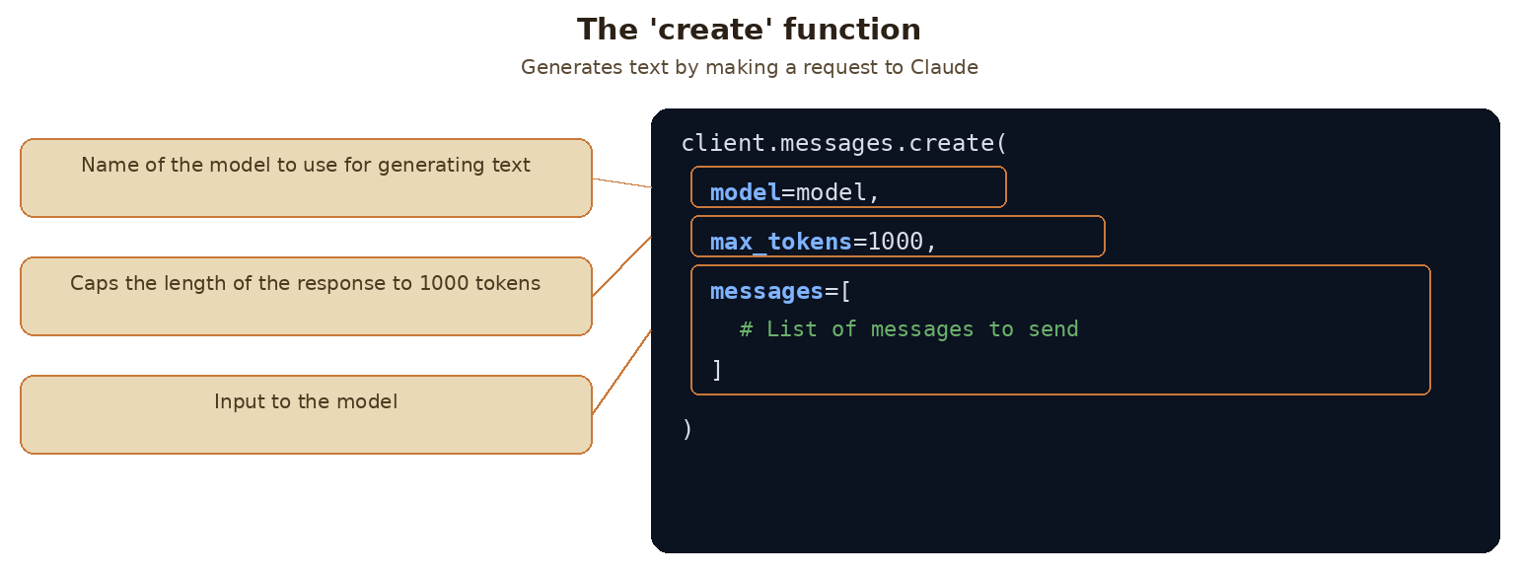
The create() function: model selects which Claude model to use, max_tokens caps the response length, and messages carries the conversation input.
Parameter | Purpose
model | The name of the Claude model you want to use
max_tokens | A safety limit on response length (not a target)
messages | The conversation history you're sending to Claude

Understanding Messages
Messages represent the conversation between you and Claude, similar to a chat application. There are two types: user messages, which are content you want to send to Claude (written by humans), and assistant messages, which are responses that Claude has generated. Each message is a dictionary with a role, either "user" or "assistant", and content, the actual text.
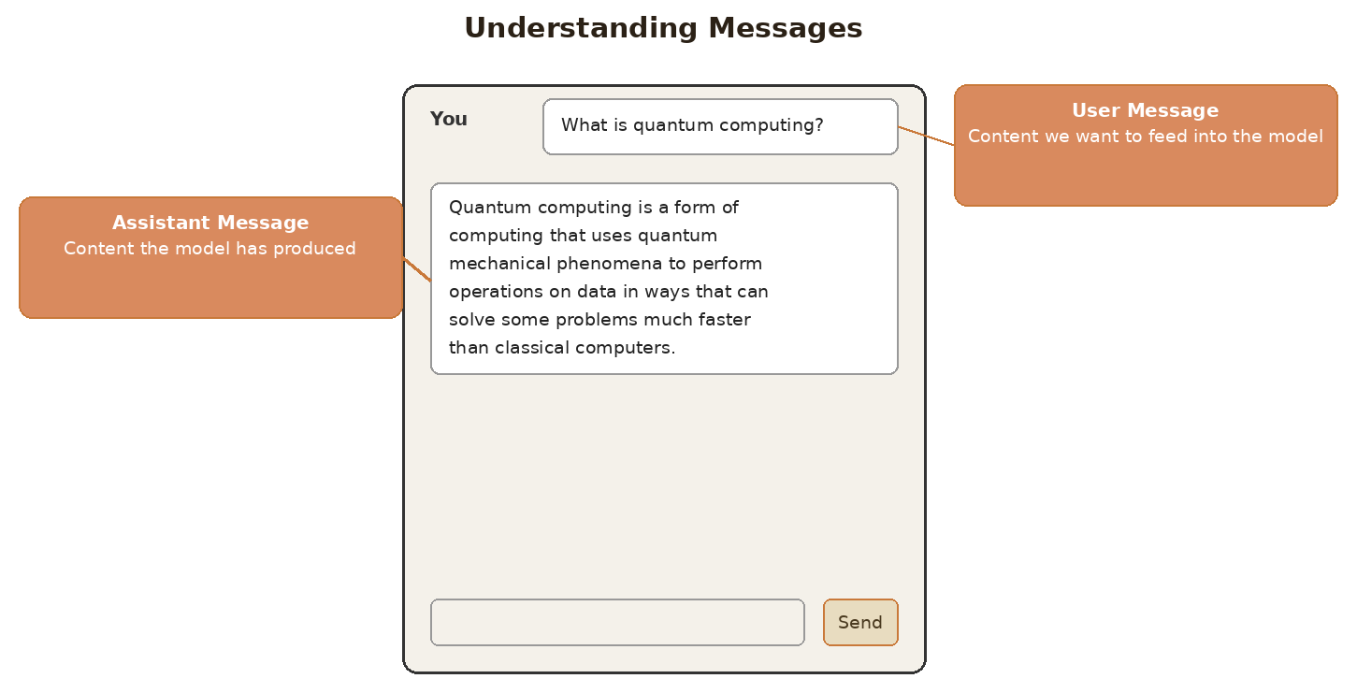
User messages feed content into the model; assistant messages carry the content the model has produced.
Role | Description
user | Content you want to send to Claude — written by you, the human
assistant | The response text that Claude has generated

Making your first request and extracting the response
Here is a complete example of a request to Claude. When you run it, Claude processes the request and returns a response object containing the generated text along with metadata about the request:
message = client.messages.create(
model=model,
max_tokens=1000,
messages=[
{
"role": "user",
"content": "What is quantum computing? Answer in one sentence."
}
]
)
The response object carries a lot of information, but you usually just want the generated text. Access it with message.content[0].text — this returns clean, readable output, e.g. "Quantum computing is a type of computation that leverages quantum mechanics principles like superposition and entanglement to process information using quantum bits (qubits), potentially solving certain complex problems exponentially faster than classical computers." With these basics in place, you can start experimenting with different prompts and building more complex interactions with Claude.
print(message.content[0].text)

Practice Questions — Lesson 2
Choose the single best answer for each question (A–E).
1. Why should the API key be stored in a .env file instead of directly in the notebook code?
A) It makes the code run faster
B) It keeps the secret key out of your source code and out of version control
C) The API only accepts keys read from .env files
D) It reduces the number of tokens used per request
E) The anthropic package cannot be imported without a .env file
2. Which three parameters does client.messages.create() require?
A) api_key, model, temperature
B) model, max_tokens, messages
C) role, content, model
D) client, model, prompt
E) messages, temperature, top_p
3. What happens if Claude's natural response would be longer than the max_tokens value you set?
A) Claude raises an error and refuses to respond
B) Generation simply stops once it hits that limit, even if Claude had more to say
C) max_tokens is ignored and Claude always finishes its thought
D) Claude automatically raises max_tokens for you
E) The request is queued until more tokens become available
4. In the messages list, what two keys make up each message dictionary?
A) "sender" and "text"
B) "user" and "assistant"
C) "role" and "content"
D) "input" and "output"
E) "prompt" and "response"
5. After calling client.messages.create() and storing the result in message, how do you extract just the generated text?
A) message.text
B) message["content"]
C) message.content[0].text
D) message.output
E) message.get_text()

Lesson 3 — Multi-Turn Conversations

Core idea
The Anthropic API is stateless — Claude doesn't store any of your conversation history, so each request is completely independent. To hold a real conversation, you must manually keep a growing list of messages in your own code and resend that entire list with every follow-up request.

Key points
- Each API call is completely independent — Claude has no memory of previous exchanges between separate requests.
- To have a real "conversation" you must: (1) manually maintain a list of messages in your code, and (2) send that complete list with every follow-up request.
- The working flow: send the initial user message → add Claude's reply as an assistant message → add the follow-up as another user message → resend the whole history.
- Three small helper functions — add_user_message, add_assistant_message, and chat — make managing this list much easier.

Why conversations feel stateless
When working with the Anthropic API, Claude doesn't store any of your conversation history — every request you make is completely independent, with no memory of previous exchanges. If you ask "What's quantum computing? Answer in one sentence," get a good reply, and then simply follow up with "Write another sentence," Claude has no idea what you're referring to: it has no memory of the quantum computing discussion, so it writes a sentence about something unrelated. This means that if you want a multi-turn conversation where Claude remembers context from earlier messages, you need to handle the conversation state entirely yourself.
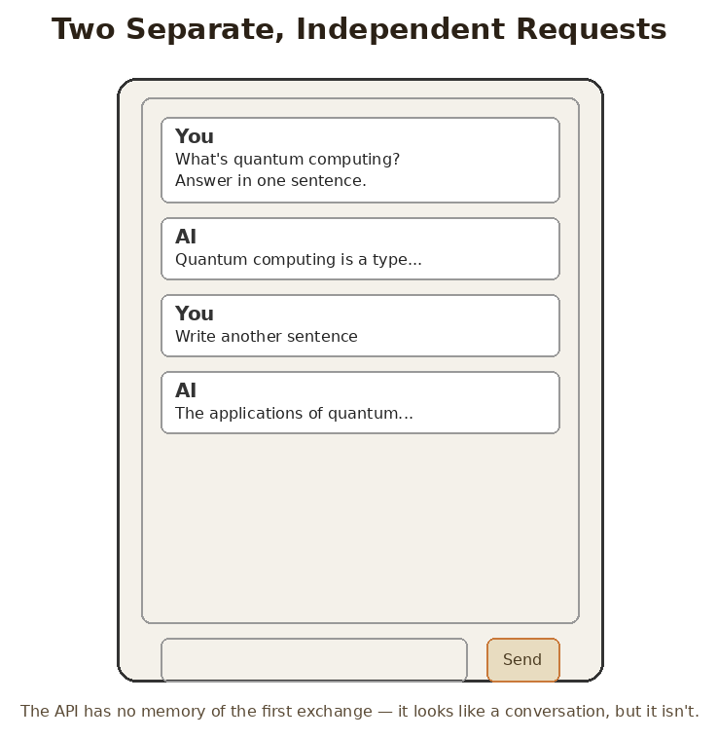
Two separate, independent requests — the API has no memory of the first exchange, even though the chat window makes it look continuous.

The problem with stateless conversations, and the fix
The Anthropic API and Claude do not store any messages. To have a "conversation" you need to: manually maintain a list of messages in your code, and provide that list of messages with each follow-up request. In practice, this means every request carries the full history of the exchange so far — not just the newest question.
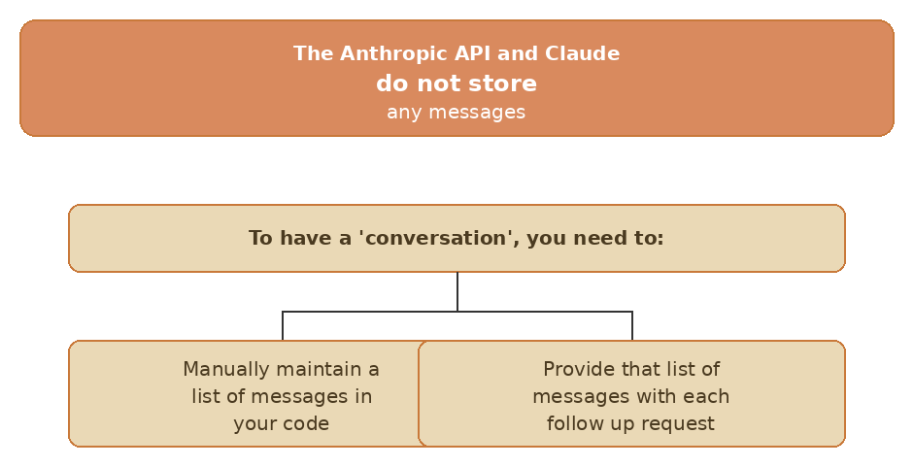
Because Claude and the API do not store any messages, your code is responsible for maintaining and resending the list.

How multi-turn conversations actually work
To maintain conversation context you need to do two things: manually maintain a list of all messages in your code, and send the complete message history with every request. The flow that actually works has four steps: send your initial user message to Claude; take Claude's response and add it to your message list as an assistant message; add your follow-up question as another user message; then send the entire conversation history to Claude again. Each new call carries every prior turn, which is exactly why Claude appears to "remember" — it's reading the whole transcript again, not recalling anything.
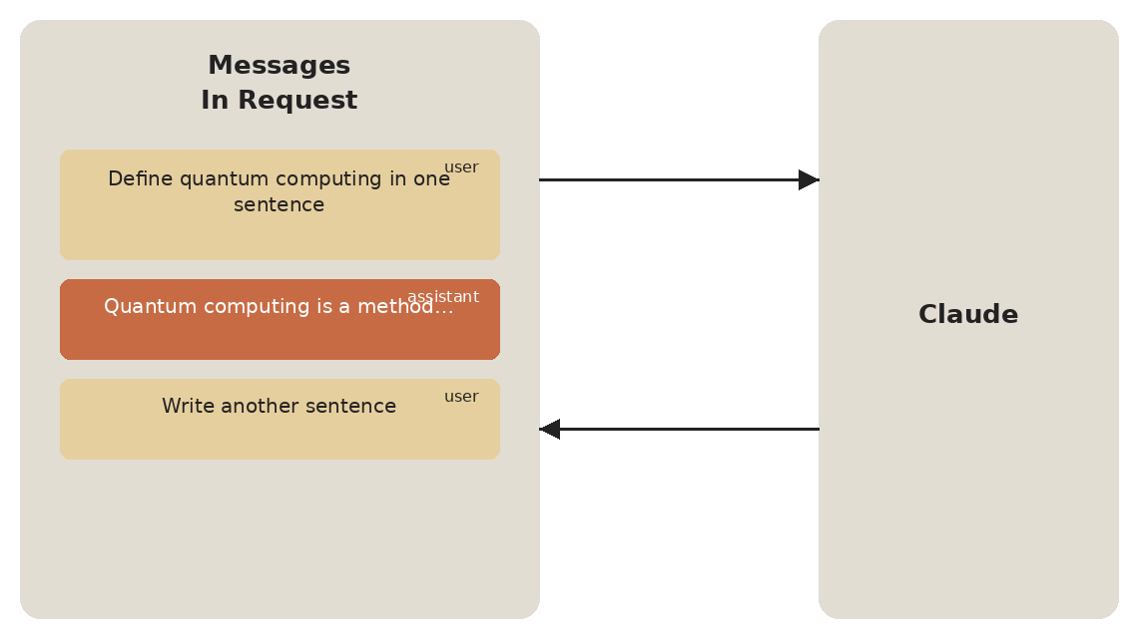
The messages list grows with every turn — user, then assistant, then user again — and the whole list is resent to Claude each time.
Step | What happens
1 | Send your initial user message to Claude
2 | Take Claude's response and add it to your message list as an assistant message
3 | Add your follow-up question as another user message
4 | Send the entire conversation history to Claude

Building helper functions
To make conversation management easier, you can create three small helper functions. add_user_message(messages, text) builds a dictionary with role "user" and the given content, and appends it to the list. add_assistant_message(messages, text) does the same with role "assistant" — typically used to record Claude's own reply. chat(messages) is a thin wrapper around client.messages.create() that always passes the same model and max_tokens, sends the current messages list, and returns just the generated text (message.content[0].text) instead of the full response object.
def add_user_message(messages, text):
user_message = {"role": "user", "content": text}
messages.append(user_message)

def add_assistant_message(messages, text):
assistant_message = {"role": "assistant", "content": text}
messages.append(assistant_message)

def chat(messages):
message = client.messages.create(
model=model,
max_tokens=1000,
messages=messages,
)
return message.content[0].text
Function | Purpose
add_user_message(messages, text) | Appends a {"role": "user", "content": text} dict to the list
add_assistant_message(messages, text) | Appends a {"role": "assistant", "content": text} dict to the list
chat(messages) | Calls client.messages.create() with the current list and returns just message.content[0].text

Putting it all together
Here's how you use these three functions to maintain a real conversation across two turns:
# Start with an empty message list
messages = []

# Add the initial user question
add_user_message(messages, "Define quantum computing in one sentence")

# Get Claude's response
answer = chat(messages)

# Add Claude's response to the conversation history
add_assistant_message(messages, answer)

# Add a follow-up question
add_user_message(messages, "Write another sentence")

# Get the follow-up response with full context
final_answer = chat(messages)
By the time of the second chat(messages) call, the list holds three entries — the original user question, Claude's assistant reply, and the new user follow-up — so Claude can finally answer "Write another sentence" with the quantum-computing context still in view.

Practice Questions — Lesson 3
Choose the single best answer for each question (A–E).
1. Why does Claude have no memory of a previous exchange when you send a new, separate API request?
A) Claude deliberately forgets messages after 60 seconds
B) The Anthropic API and Claude do not store any conversation history — each request is independent
C) Claude only remembers the very last message you sent
D) Memory is disabled unless you are on a premium plan
E) The server caches only the first message of the day
2. What two things must you do to maintain conversation context across multiple turns?
A) Increase max_tokens and lower the temperature
B) Manually maintain a list of messages and send the complete history with every request
C) Store the API key inside every message
D) Call a separate "remember" endpoint before each request
E) Use a different model for each turn of the conversation
3. What is the correct order of steps in a working multi-turn flow?
A) Add the follow-up question, send the history, send the initial message, add the response
B) Send the initial user message → add Claude's reply as an assistant message → add the follow-up as a user message → send the entire history
C) Send the entire history first, then add a user message, then discard the history
D) Add an assistant message, add a user message, then discard both before sending
E) Send the follow-up question before the initial message
4. In the helper function add_assistant_message(messages, text), what does it actually do?
A) It sends a new request to Claude
B) It appends {"role": "assistant", "content": text} to the messages list
C) It deletes the previous user message from the list
D) It converts the text into tokens
E) It prints Claude's response to the console
5. What does the chat(messages) helper function return?
A) The full response object, including all metadata
B) A new, empty messages list
C) The generated text — message.content[0].text
D) The role of the most recent message
E) Nothing; it only prints the response

Lesson 4 — System Prompts

Core idea
System prompts are a powerful way to customize how Claude responds to user input. Instead of getting generic answers, you can shape Claude's tone, style, and approach to match your specific use case. A system prompt is just a plain string, and you pass it to create() as its own system parameter — it never becomes part of the messages list.

Key points
- A system prompt gives Claude guidance on how to respond — not what question to answer.
- Claude will try to respond the same way someone in the specified role would respond.
- System prompts help keep Claude on task across a long conversation.
- You define them as plain strings and pass them into the create function call as system=system_prompt.
- Claude's API does not accept system=None — so a reusable chat function must add the system key conditionally.

Why system prompts matter
Consider building a math tutor chatbot. When a student asks "How do I solve 5x + 2 = 3 for x?", you want Claude to act like a real tutor, not just spit out the answer. A good math tutor should initially give hints rather than complete solutions, patiently walk students through problems step by step, and show solutions for similar problems as examples. You definitely don't want Claude to immediately give direct answers, or to tell students to just use a calculator. Notice that none of this is about the student's question — it is about how Claude should behave when answering it. That is exactly the job of a system prompt.
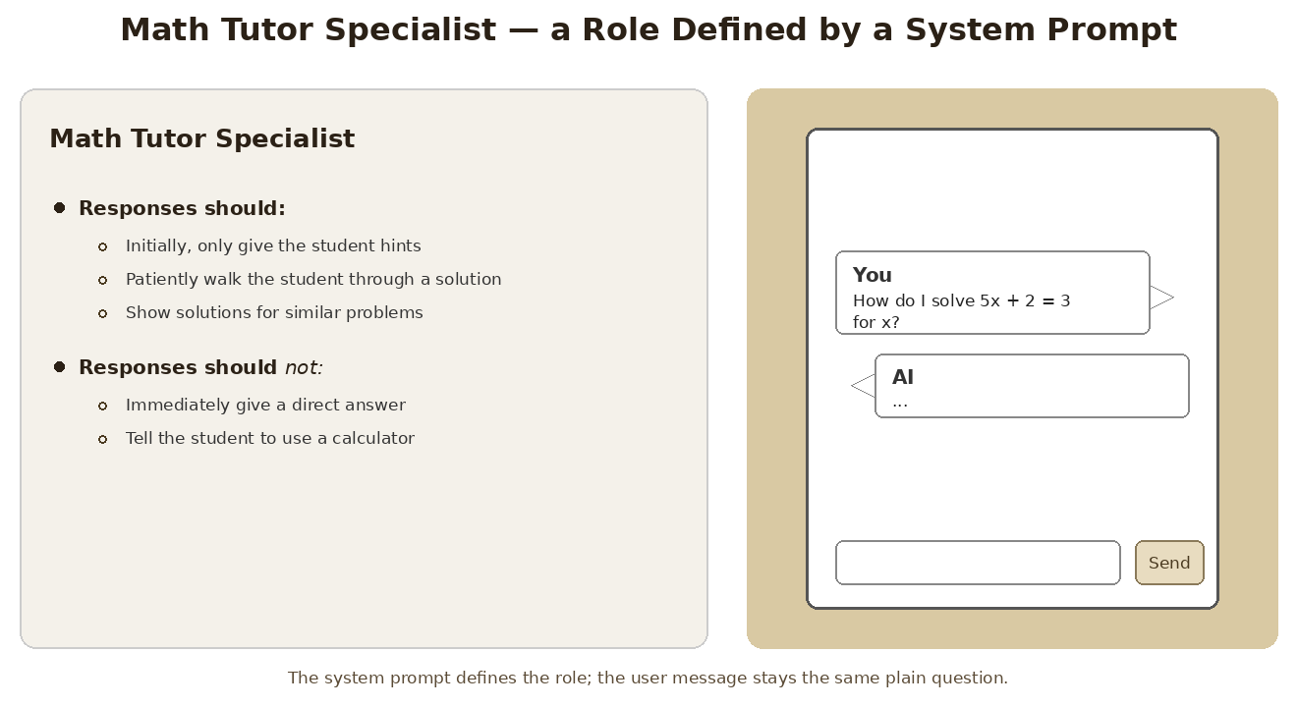
The Math Tutor Specialist role: a set of behaviours defined once in the system prompt, applied to every user question.
Responses should | Responses should NOT
Initially, only give the student hints | Immediately give a direct answer
Patiently walk the student through a solution | Tell the student to use a calculator
Show solutions for similar problems | —

How system prompts work
System prompts provide Claude with guidance on how to respond. You define them as plain strings and pass them into the create function call. The key benefits are: system prompts provide Claude guidance on how to respond; Claude will try to respond in the same way someone in the specified role would respond; and they help keep Claude on task.
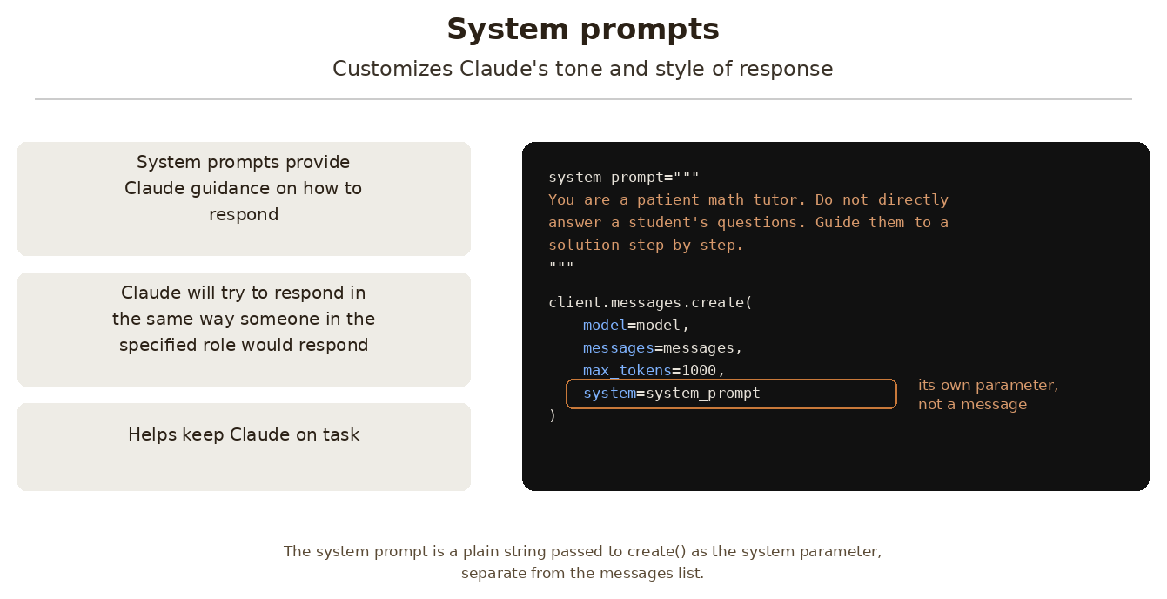
System prompts customize Claude's tone and style of response — passed as the system parameter, separate from messages.
Benefit | What it means in practice
Guidance on how to respond | You control tone, style and approach without changing the user's question
Role-consistent behaviour | Claude responds the way someone in the specified role would respond
Keeps Claude on task | Reduces drift into off-topic or unwanted answers across a long conversation

The basic structure
Here's the basic structure. Define the system prompt as a triple-quoted string, then pass it as the system argument alongside the usual model, messages and max_tokens:
system_prompt = """
You are a patient math tutor.
Do not directly answer a student's questions.
Guide them to a solution step by step.
"""

client.messages.create(
model=model,
messages=messages,
max_tokens=1000,
system=system_prompt
)

Seeing the difference
Without a system prompt, Claude gives a complete step-by-step solution immediately. This might be helpful, but it doesn't encourage the student to think through the problem themselves. With the math tutor system prompt, Claude's response changes dramatically. Instead of providing the full solution, Claude asks guiding questions like "What do you think would be a good first step to isolate x? Consider what operation we might need to perform on both sides to start moving terms around." The user message is identical in both cases — only the system prompt changed.
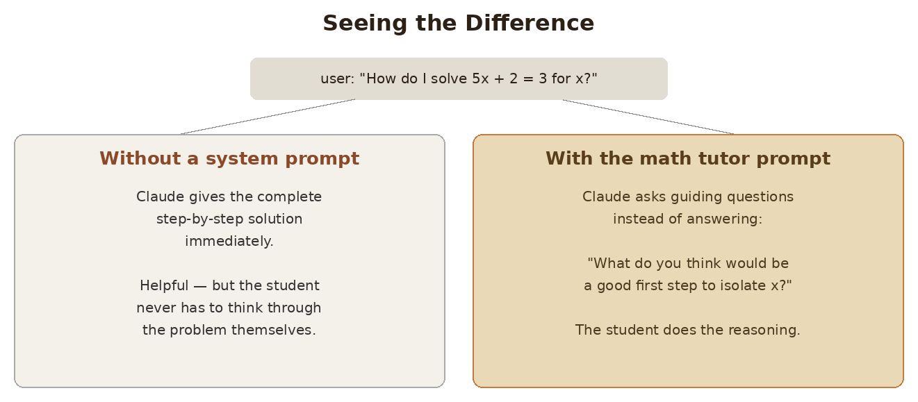
Same user question, two very different responses — the system prompt is the only variable.

Building a flexible chat function
Rather than hard-coding system prompts, you can make your chat function more reusable by accepting system prompts as parameters. Build a params dictionary with the always-required keys, then add the system key only if a system prompt was actually supplied, and finally unpack the dictionary into create() with **params:
def chat(messages, system=None):
params = {
"model": model,
"max_tokens": 1000,
"messages": messages,
}

if system:
params["system"] = system

message = client.messages.create(**params)
return message.content[0].text
This approach handles an important detail: Claude's API doesn't accept system=None, so you need to conditionally include the system parameter only when it's provided. If you passed system=None unconditionally, the request would fail.

Calling it with or without a system prompt
Now you can call your chat function either way, and the same function body handles both:
# Without system prompt
answer = chat(messages)

# With system prompt
system = """
You are a patient math tutor.
Do not directly answer a student's questions.
Guide them to a solution step by step.
"""
answer = chat(messages, system=system)
System prompts are essential for creating AI applications that behave consistently and appropriately for their intended purpose. They transform generic AI responses into specialized, role-appropriate interactions.

Practice Questions — Lesson 4
Choose the single best answer for each question (A–E).
1. What is the main purpose of a system prompt?
A) To increase the maximum number of tokens Claude can generate
B) To give Claude guidance on how to respond, shaping its tone, style and approach
C) To store the conversation history so Claude remembers previous turns
D) To authenticate the request in place of the API key
E) To translate the user's question into English before sending it
2. How is a system prompt passed to the API?
A) As a message with role "system" appended to the messages list
B) As a plain string passed to create() in its own "system" parameter
C) As a separate request made before the main one
D) As a field inside the user message's content
E) As an environment variable named SYSTEM_PROMPT
3. In the math tutor example, which behaviour does the system prompt try to PREVENT?
A) Giving the student hints before the full solution
B) Walking the student through the problem step by step
C) Immediately giving a direct answer to the student's question
D) Showing a solution to a similar problem as an example
E) Asking the student a guiding question
4. Why does the flexible chat function add the system key conditionally, inside an if statement?
A) Because system prompts are billed separately and must be opted into
B) Because Claude's API does not accept system=None, so the key must be omitted when no prompt is given
C) Because the system parameter can only be used on the very first request
D) Because Python dictionaries cannot hold more than three keys
E) Because the system prompt must always be added after the response is returned
5. In the flexible chat function, what does **params do in client.messages.create(**params)?
A) It converts the dictionary into a list of messages
B) It unpacks the dictionary into keyword arguments for the create() call
C) It multiplies the max_tokens value by two
D) It marks the parameters as optional so the API can ignore them
E) It sends the parameters as a raw JSON string instead of keyword arguments

Lesson 5 — Temperature

Core idea
Temperature is a decimal value between 0 and 1 that directly influences the selection probabilities Claude uses when picking the next token. It's like adjusting the "creativity dial" on Claude's responses: near 0 the output is highly deterministic, near 1 the probability mass spreads out and the output becomes more varied and creative.

Key points
- Text generation has three key steps: Tokenization, Prediction, and Sampling.
- Temperature acts on the sampling step — it reshapes the probability distribution, it does not change what the model predicts.
- Low temperature (near 0) = more deterministic — Claude almost always picks the highest-probability token.
- High temperature (near 1) = more random — probability is distributed more evenly across options.
- Different tasks call for different ranges: 0.0–0.3 low, 0.4–0.7 medium, 0.8–1.0 high.
- In code, temperature is just another key in the params dictionary passed to create().

How Claude generates text
Before diving into temperature, it helps to understand Claude's text generation process. When you send Claude a prompt like "What do you think?", it goes through three key steps: Tokenization — breaking your input into smaller chunks; Prediction — calculating probabilities for possible next words; and Sampling — choosing a token based on those probabilities. Temperature only affects that last step.
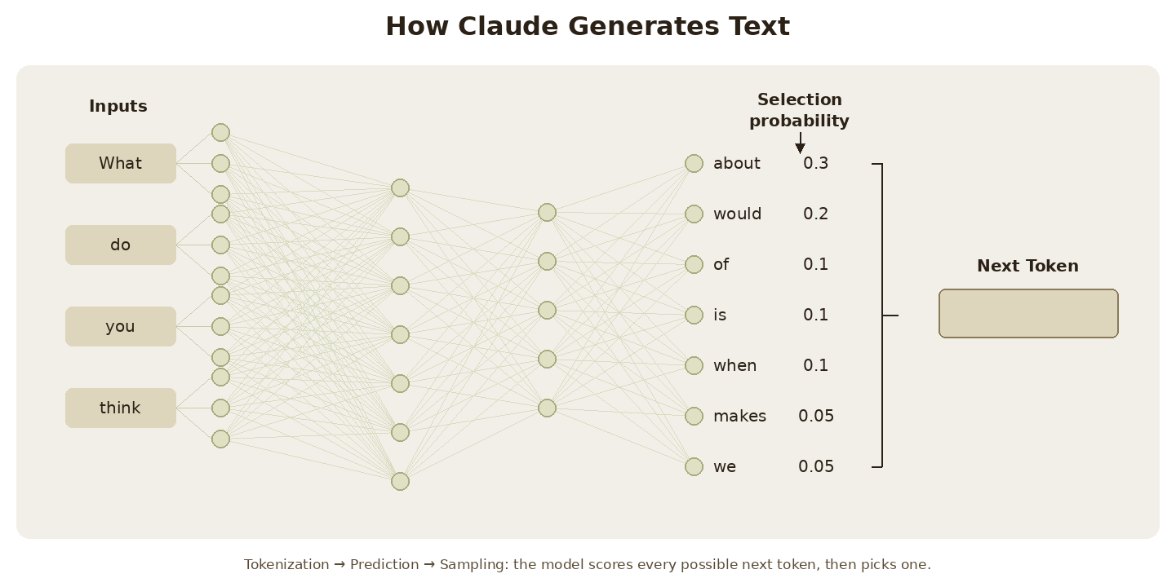
Inputs flow through the model to a selection probability for every candidate token; one of them becomes the next token.
Step | What happens
Tokenization | Breaking your input into smaller chunks
Prediction | Calculating probabilities for possible next words
Sampling | Choosing a token based on those probabilities

The probability distribution
In this example, Claude might assign a 30% probability to "about", 20% to "would", 10% to "of", and so on. The model then selects one token and repeats this entire process to build complete sentences. Every single word in a long response is the result of one full pass through this loop.
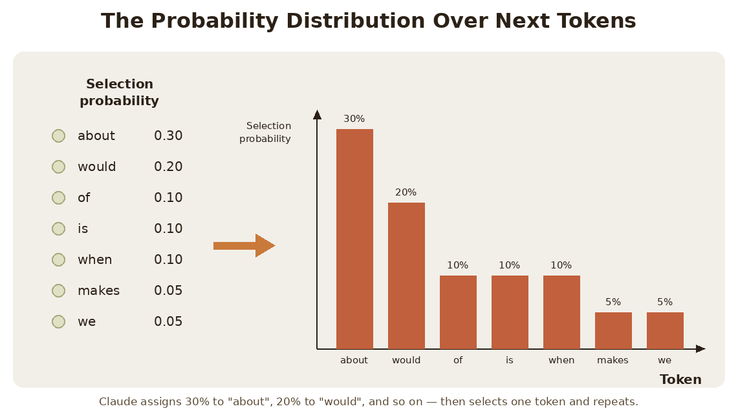
The same numbers, drawn as a distribution: "about" at 30% dominates, but six other tokens still hold probability.

What temperature actually changes
Temperature is a decimal value between 0 and 1 that directly influences these selection probabilities. At low temperatures (near 0), Claude becomes very deterministic — it almost always picks the highest probability token. At high temperatures (near 1), Claude distributes probability more evenly across options, leading to more varied and creative outputs. Notice what this means: the underlying ranking doesn't change — "about" is still the most likely token in both charts — but how strongly Claude favours it does.
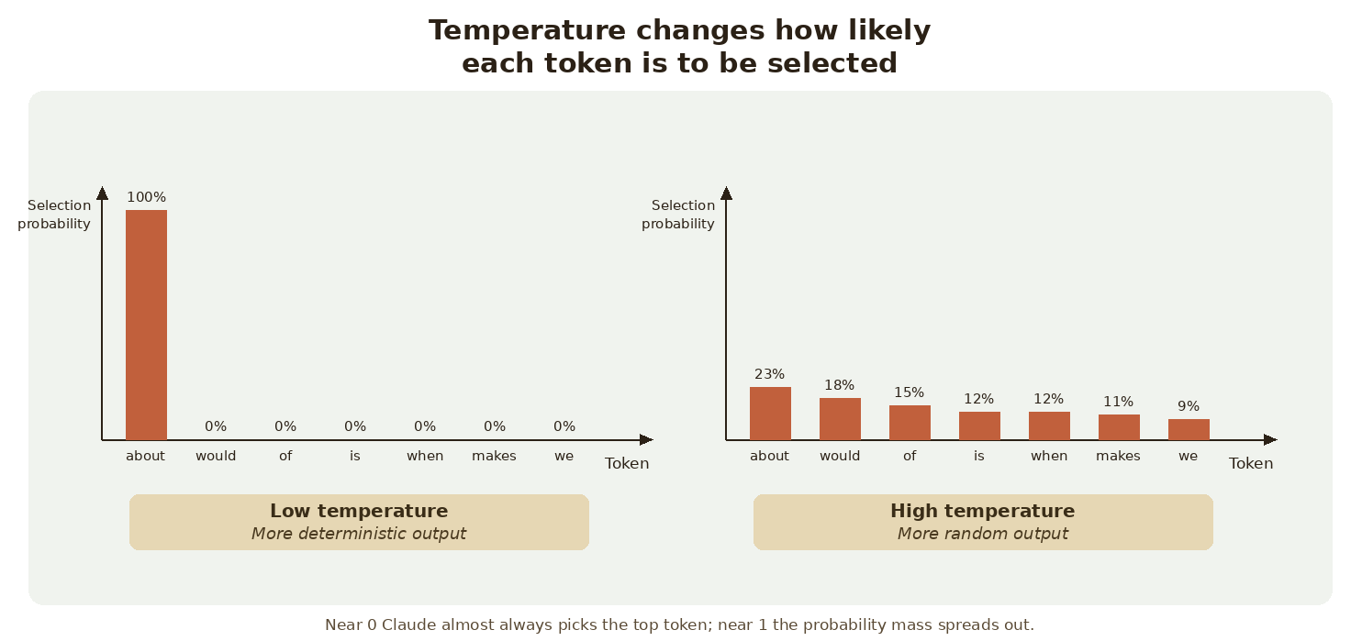
Low temperature collapses the distribution onto the top token; high temperature flattens it across all candidates.
Temperature | Effect on the distribution
0.0 (near zero) | "about" gets 100% probability — completely deterministic output
~0.5 (middle) | Top token still dominates, but alternatives keep meaningful probability
1.0 (near one) | Probabilities spread more evenly across all possible tokens — randomness and creativity

You can see temperature in action with Claude's interactive demo, where a slider moves between 0 (Deterministic) and 1 (More Random) and the bar chart redraws live. At temperature 0.0, "about" gets 100% probability — completely deterministic. At temperature 1.0, probabilities spread more evenly across all possible tokens, introducing randomness and creativity.

Choosing the right temperature
Different tasks call for different temperature ranges. The rule of thumb: the more you need the answer to be correct and repeatable, the lower the temperature; the more you need it to be original, the higher.
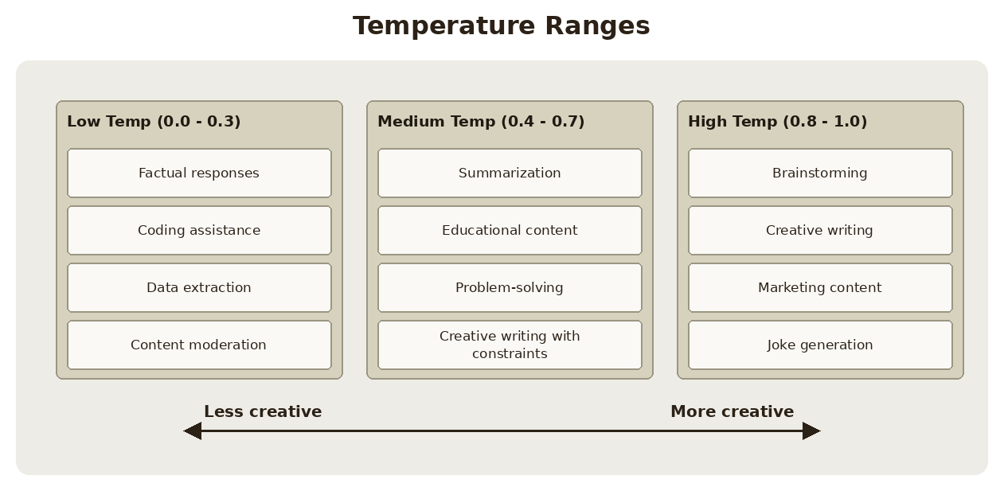
Three practical bands, from least to most creative.
Range | Best suited for
Low Temperature (0.0 - 0.3) | Factual responses, coding assistance, data extraction, content moderation
Medium Temperature (0.4 - 0.7) | Summarization, educational content, problem-solving, creative writing with constraints
High Temperature (0.8 - 1.0) | Brainstorming, creative writing, marketing content, joke generation

Implementing temperature in code
Adding temperature support to your chat function is straightforward. The key changes are adding temperature=1.0 as a parameter and including "temperature": temperature in the params dictionary. Unlike the system prompt, temperature always has a valid value, so it does not need the conditional treatment:
def chat(messages, system=None, temperature=1.0):
params = {
"model": model,
"max_tokens": 1000,
"messages": messages,
"temperature": temperature
}

if system:
params["system"] = system

message = client.messages.create(**params)
return message.content[0].text

Testing temperature effects
To see temperature in action, try generating movie ideas with different settings:
# Low temperature - more predictable
answer = chat(messages, temperature=0.0)

# High temperature - more creative
answer = chat(messages, temperature=1.0)
At temperature 0.0, you might consistently get responses like "A time-traveling archaeologist must prevent ancient artifacts from being stolen." At temperature 1.0, you'll see much more variety in themes, characters, and plot elements. Running the same prompt twice is the fastest way to feel the difference: at 0.0 the answers barely change, at 1.0 they diverge.

Practice Questions — Lesson 5
Choose the single best answer for each question (A–E).
1. What are the three key steps in Claude's text generation process?
A) Embedding, Contextualization, Generation
B) Tokenization, Prediction, Sampling
C) Request, Response, Retry
D) Encoding, Decoding, Formatting
E) Prediction, Validation, Sampling
2. What is temperature?
A) An integer between 1 and 100 that sets the maximum response length
B) A decimal value between 0 and 1 that influences the token selection probabilities
C) A setting that chooses which model version handles the request
D) The number of tokens Claude processes per second
E) A flag that turns the system prompt on or off
3. What happens at a temperature near 0?
A) Claude distributes probability evenly across all candidate tokens
B) Claude becomes very deterministic and almost always picks the highest-probability token
C) Claude stops generating after a single token
D) Claude ignores the messages list entirely
E) Claude produces its most creative and varied output
4. Which temperature range is most appropriate for data extraction and coding assistance?
A) 0.0 - 0.3
B) 0.4 - 0.7
C) 0.8 - 1.0
D) 1.5 - 2.0
E) Temperature has no effect on these tasks
5. In the updated chat function, how is temperature added to the request?
A) It is appended to the messages list as its own message
B) It is included as "temperature": temperature in the params dictionary
C) It must be set inside the system prompt text
D) It is passed only when it is different from None, inside an if statement
E) It is configured once in the .env file and never passed to create()

Lesson 6 — Response Streaming

Core idea
When building chat applications with Claude there's a significant user experience challenge: responses can take 10-30 seconds to generate, leaving users staring at a loading spinner. The solution is response streaming, which lets users see text appear chunk by chunk as Claude generates it, creating a much more responsive feel.

Key points
- Without streaming, your server waits for the complete response before sending anything back to the client.
- With streaming, Claude sends an initial response immediately, then a series of events, each containing a small piece of the overall response.
- All of those events are part of a single request to Claude — not many separate requests.
- Of the six event types, only the ContentBlockDelta events contain the actual generated text.
- Enable it by adding stream=True to messages.create(), which returns a stream you iterate over.
- stream.get_final_message() gives you the complete assembled message once streaming finishes.

The problem with standard responses
In a typical chat setup, your server sends a user message to Claude and waits for the complete response before sending anything back to the client. This creates an awkward delay where users have no feedback that anything is happening. The generation itself can take 10-30 seconds for a full response, and during all of that time the interface has nothing to show.
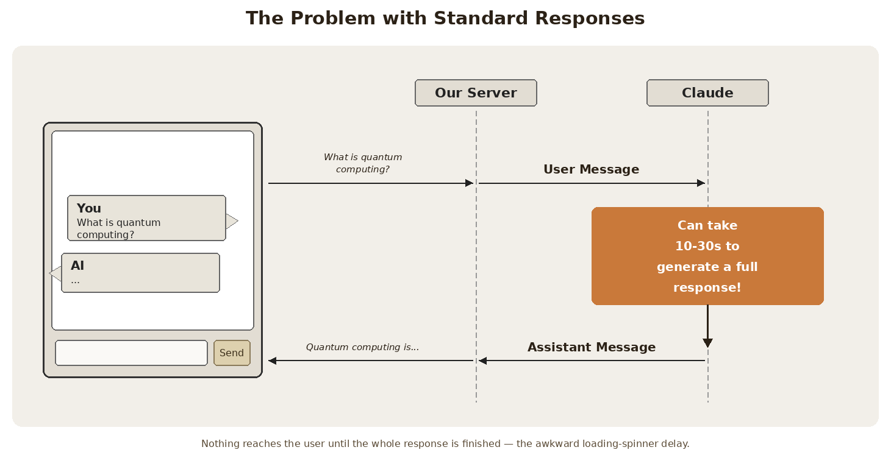
Standard (non-streaming) flow: one long wait on Claude's side, then a single Assistant Message comes back.

How streaming works
With streaming enabled, Claude immediately sends back an initial response indicating it has received your request and is starting to generate text. Then you receive a series of events, each containing a small piece of the overall response. Your server can forward these text chunks to your client application as they arrive, allowing users to see the response building up word by word. All of these events are part of a single request to Claude.
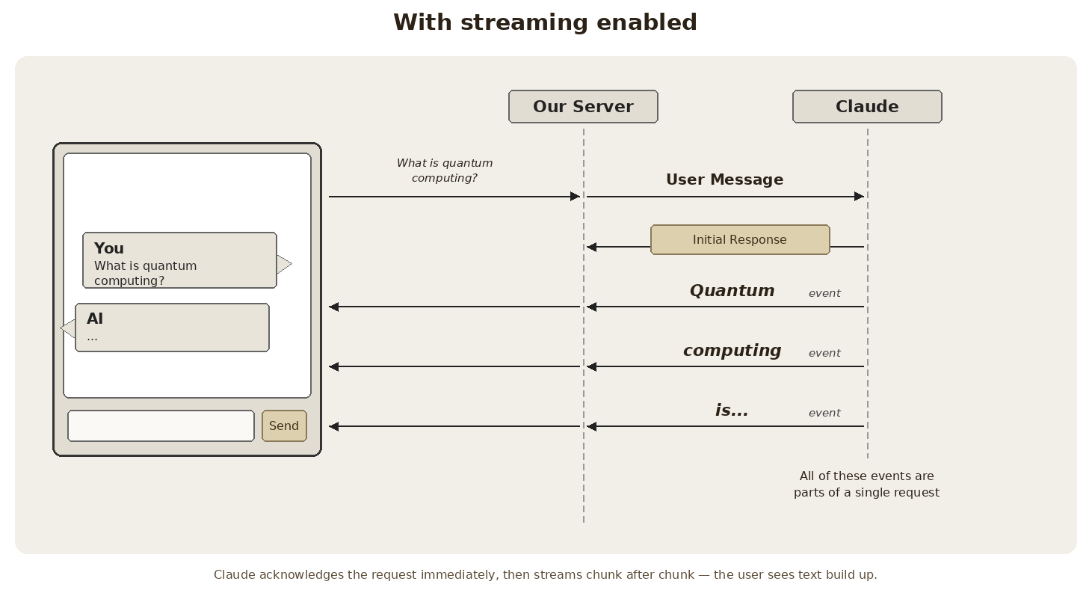
Streaming flow: Initial Response first, then one event per chunk — "Quantum", "computing", "is..." — all inside one request.
Without streaming | With streaming
Server waits for the complete response | Claude returns an initial response immediately
Client gets one Assistant Message at the end | Client gets many small text chunks as they arrive
User sees a loading spinner for 10-30s | User sees the answer build up word by word

Understanding stream events
When you enable streaming, Claude sends back several types of events. Knowing which one carries the text is the whole point: only ContentBlockDelta does.
- MessageStart — a new message is being sent.
- ContentBlockStart — start of a new block containing text, tool use, or other content.
- ContentBlockDelta — chunks of the actual generated text.
- ContentBlockStop — the current content block has been completed.
- MessageDelta — the current message is complete.
- MessageStop — end of information about the current message.
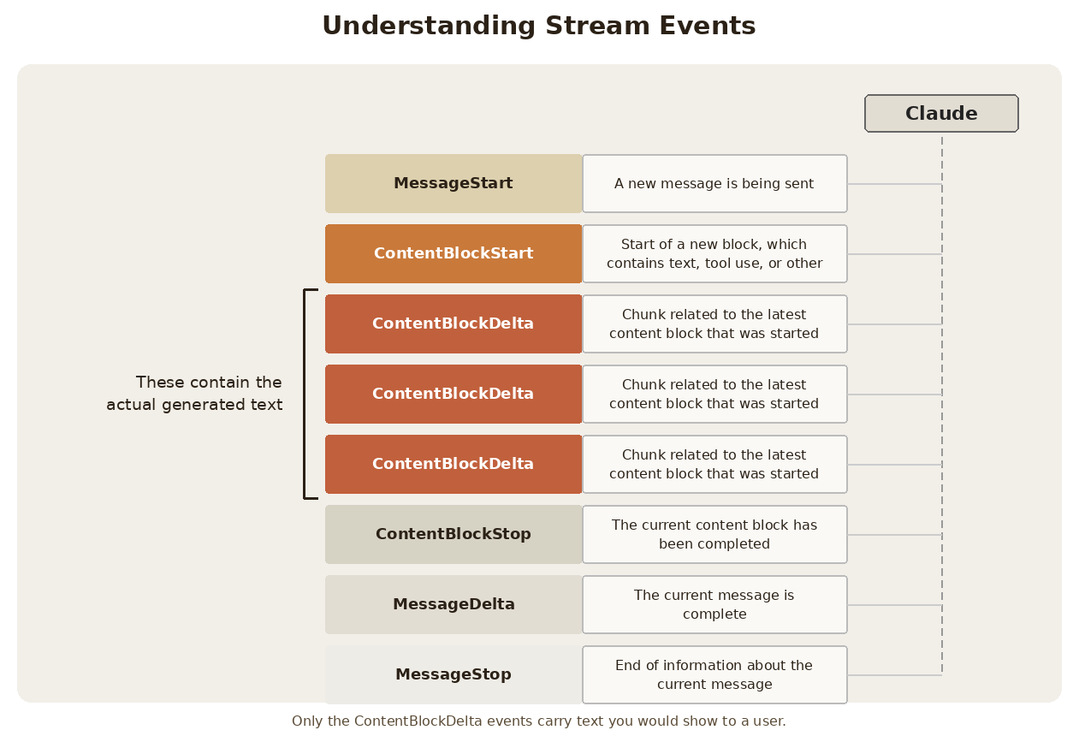
The event sequence for a single streamed response — the three ContentBlockDelta events in the middle carry the text.
Event | Meaning
MessageStart | A new message is being sent
ContentBlockStart | Start of a new block containing text, tool use, or other content
ContentBlockDelta | Chunks of the actual generated text — the ones you display to users
ContentBlockStop | The current content block has been completed
MessageDelta | The current message is complete
MessageStop | End of information about the current message

Basic streaming implementation
To enable streaming, add stream=True to your messages.create call. Instead of returning a finished message object, create() now returns a stream you iterate over with a normal for loop — each iteration hands you one event:
messages = []
add_user_message(messages, "Write a 1 sentence description of a fake database")

stream = client.messages.create(
model=model,
max_tokens=1000,
messages=messages,
stream=True
)

for event in stream:
print(event)
Printing the raw events is the best way to see the lifecycle for yourself: you'll get a MessageStart, a ContentBlockStart, a run of ContentBlockDelta events, then ContentBlockStop, MessageDelta and MessageStop.

Simplified text streaming
Rather than manually parsing events, you can use the SDK's simplified streaming interface that extracts just the text content. This approach automatically filters out everything except the actual text content, which is usually what you need for displaying responses to users:
with client.messages.stream(
model=model,
max_tokens=1000,
messages=messages
) as stream:
for text in stream.text_stream:
print(text, end="")

Getting the complete message
Streaming the chunks is great for display, but you usually still need the complete assembled message — to append it to your conversation history, or to read the usage and stop reason. The stream object gives you that with get_final_message(), called after the loop has finished consuming the stream:
with client.messages.stream(
model=model,
max_tokens=1000,
messages=messages
) as stream:
for text in stream.text_stream:
print(text, end="")

final_message = stream.get_final_message()

print(final_message)
This gives you the best of both worlds: the user watches the text appear in real time, and your code still ends up holding the same full message object it would have received from a normal, non-streaming request.

Practice Questions — Lesson 6
Choose the single best answer for each question (A–E).
1. What user experience problem does response streaming solve?
A) Responses exceed the max_tokens limit and get cut off
B) Responses can take 10-30 seconds, leaving users staring at a loading spinner
C) The API key is exposed to the client
D) Claude forgets the conversation history between turns
E) The model picks low-probability tokens too often
2. Which stream event type contains the actual generated text?
A) MessageStart
B) ContentBlockStart
C) ContentBlockDelta
D) MessageDelta
E) MessageStop
3. How do you enable streaming on a messages.create call?
A) By setting temperature=0.0
B) By adding stream=True to the create call
C) By passing a system prompt that requests streaming
D) By calling create() once per chunk you want back
E) By setting max_tokens to a very small value
4. How many requests to Claude do all the streamed events belong to?
A) One request per event
B) One request per content block
C) A single request — all the events are parts of it
D) Two requests: one for the initial response, one for the text
E) It depends on the temperature setting
5. What does stream.get_final_message() give you?
A) Only the last text chunk that was streamed
B) The complete assembled message object, after the stream has been consumed
C) A new empty message ready for the next turn
D) The number of events that were received
E) Nothing — it only closes the connection

Lesson 7 — Structured Data

Core idea
When you need Claude to generate structured data like JSON, Python code, or bulleted lists, you run into a common problem: Claude wants to be helpful and adds explanatory text around your content. The fix is to combine assistant message prefilling with stop sequences — you start Claude's answer for it, and you tell the API where to cut generation off.

Key points
- By default Claude wraps generated data in markdown code blocks and adds explanation — usually great, but not when you need raw data.
- Prefilling means adding an assistant message to the list yourself, so Claude continues from where you left it.
- Stop sequences tell the API to end generation immediately when a given string appears.
- Together: prefill with ```json and stop on ``` — you get only the content between the fences.
- The technique generalizes: identify what Claude naturally wants to wrap your content in, then use that as the prefill and the stop sequence.
- Clean up leftover newlines with text.strip() before parsing.

The use case
Consider building a web app that generates AWS EventBridge rules. Users enter a description, click generate, and expect to see clean JSON they can immediately copy and use. If Claude returns the JSON wrapped in markdown code blocks with explanatory text, users can't simply copy the entire response — they have to manually select just the JSON portion. That friction is exactly what this lesson removes.
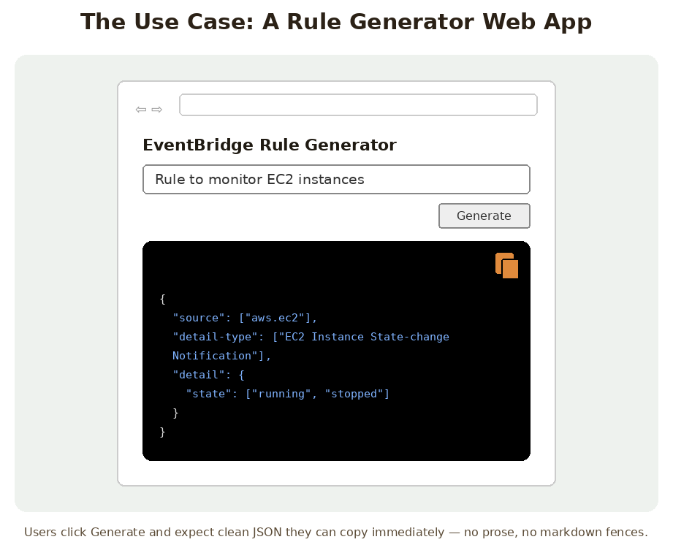
The app the lesson is built around: a description goes in, copy-ready JSON must come out.

The problem with default responses
By default, when you ask Claude to generate JSON, you might get the JSON correctly — but wrapped in ```json fences and followed by a sentence like "This rule captures EC2 instance state changes when instances start running." The JSON is right; the packaging is the problem. For a web app where users need to copy the raw JSON, this creates friction in the user experience, and for code that needs to call json.loads() it means stripping the fences and the prose first.
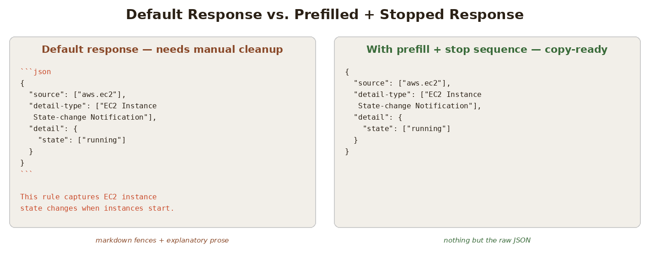
Left: what you get by default. Right: what prefilling plus a stop sequence produces.

The solution: prefilling + stop sequences
You can combine assistant message prefilling with stop sequences to get exactly the content you want. You add the user message as usual, then add an assistant message containing just the opening fence, and pass a stop sequence for the closing fence:
messages = []

add_user_message(messages, "Generate a very short event bridge rule as json")
add_assistant_message(messages, "```json")

text = chat(messages, stop_sequences=["```"])
This technique works by a four-step chain of reasoning:
- The user message tells Claude what to generate.
- The prefilled assistant message makes Claude think it already started a markdown code block.
- Claude continues by writing just the JSON content.
- When Claude tries to close the code block with ```, the stop sequence immediately ends generation.
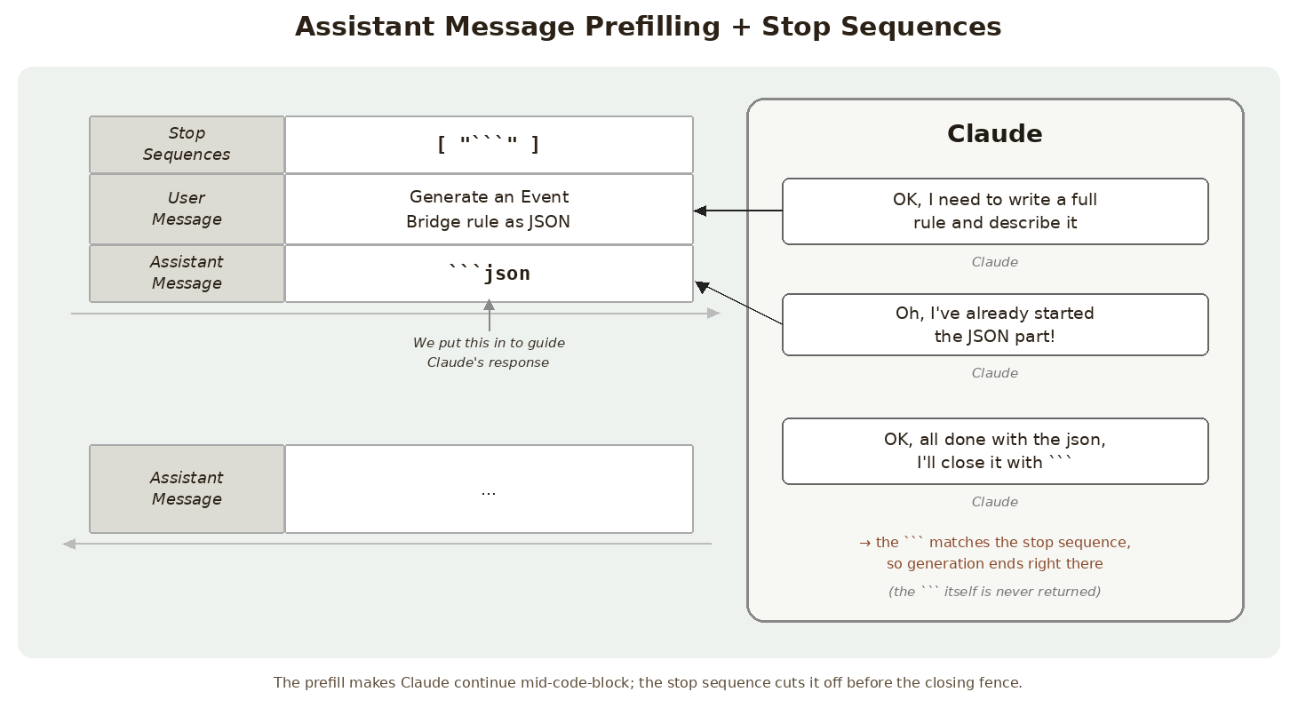
Claude would normally write a full rule plus a description — but the prefill makes it believe the JSON block already started.
Piece | Role in the technique
User message | Tells Claude what to generate
Prefilled assistant message (```json) | Makes Claude believe the code block already started, so it continues with content
Stop sequence (```) | Ends generation the moment Claude tries to close the block
Result | Clean JSON with no markdown formatting and no commentary

Processing the response
You might notice some extra newline characters in the response — the prefill ends with the fence, so Claude's continuation usually starts on a new line. These are easy to handle: strip the whitespace before parsing.
import json

# Clean up and parse the JSON
clean_json = json.loads(text.strip())

Beyond JSON
This technique isn't limited to JSON generation. Use it anytime you need structured data without commentary: Python code snippets, bulleted lists, CSV data, or any formatted content where you want just the content, not explanations. The key is identifying what Claude naturally wants to wrap your content in, then using that as your prefill and stop sequence. For code, it's usually markdown code blocks. For lists, it might be different formatting markers.
Content type | Typical prefill / stop sequence
JSON | Prefill "```json", stop on "```"
Python code snippets | Prefill "```python", stop on "```"
CSV data | Prefill "```csv" or the header row, stop on "```"
Bulleted lists | Prefill the first list marker, stop on whatever closes or follows the list

This approach gives you precise control over Claude's output format, making it much easier to integrate AI-generated content into applications where clean, structured data is essential.

Practice Questions — Lesson 7
Choose the single best answer for each question (A–E).
1. What problem does this lesson's technique solve?
A) Claude generates JSON that is syntactically invalid
B) Claude wraps generated content in markdown fences and adds explanatory text
C) Claude cannot generate JSON at all without a system prompt
D) Claude forgets the conversation history between requests
E) Claude takes too long to generate a response
2. What is assistant message prefilling?
A) Sending the same user message twice to reinforce the instruction
B) Adding an assistant message to the list yourself, so Claude continues from it
C) Setting temperature to 0.0 so the output is deterministic
D) Caching Claude's previous response on your server
E) Passing the desired output format inside the system parameter
3. In the example, what are the prefill and the stop sequence?
A) Prefill "{", stop sequence "}"
B) Prefill "```json", stop sequence "```"
C) Prefill "json", stop sequence "end"
D) Prefill "```", stop sequence "```json"
E) There is no prefill — only a stop sequence is used
4. What happens when Claude tries to close the code block?
A) Claude keeps going and adds an explanation after the fence
B) The stop sequence matches and generation immediately ends
C) The request fails with an error
D) The closing fence is returned but the JSON is discarded
E) Claude restarts the response from the beginning
5. According to the lesson, how do you apply this technique to content other than JSON?
A) You cannot — it only works for JSON
B) Identify what Claude naturally wants to wrap the content in, and use that as the prefill and stop sequence
C) Always prefill with "```json" regardless of the content type
D) Raise max_tokens until the commentary no longer fits
E) Add a stop sequence for every English word you want to avoid

